


Cairo University
Faculty of Computers & Artificial Intelligence
Operations Research & Decision Support Dept.

Egyptian Premier League Schedule Optimizer
The Graduation Project Submitted to
The Faculty of Computers and Artificial Intelligence,
Cairo University
In Partial Fulfillment of the Requirements for the Bachelor Degree
In
Operations Research and Decision Support

Under Supervision of:
Dr. Sally Kassem
Eng. Rawaa Hesham

CAIRO UNIVERSITY
February, 2026

Presented by:

Rawan Ehab – 20220133
Mohamed Osama – 20220477
Abd El-Rahman Ashraf – 20220189
Ghassan Tarek – 20220239
Ibrahim Medhat – 20221003

ABSTRACT
The Egyptian Premier League scheduling process has evolved over time and is no longer entirely manual, and already considers multiple operational factors such as competition calendars, stadium availability, and security requirements. However, despite these improvements, the scheduling process still faces recurring challenges, including frequent postponements, uneven rest periods between teams, congestion caused by overlapping competitions, and difficulties in maintaining a standard league format within a fixed seasonal timeframe. These issues indicate that the existing scheduling approach lacks a unified optimization framework capable of evaluating all constraints and objectives simultaneously.
This project presents an optimization-based scheduling system using Integer Linear Programming (ILP) to enhance the current scheduling process rather than replace it. The league season is modeled as a constrained optimization problem where matches are assigned to predefined calendar slots and venues while respecting competition rules, continental commitments, security constraints, and fairness considerations. The system was implemented using Python, where structured data inputs are combined with mathematical constraints and objective functions to systematically evaluate scheduling alternatives. Optimization solvers are then used to identify schedules that satisfy all hard constraints while improving overall balance and efficiency.

DECLARATION

We hereby declare that our dissertation is entirely our work and genuine/original. We understand that in case of discovery of any PLAGIARISM at any stage, our group will be assigned an F (FAIL) grade and it may result in withdrawal of our Bachelor’s degree.

Group members:

Name Signature

Rawan Ehab

Mohamed Osama

Abd El-Rahman Ashraf

Ghassan Tarek

Ibrahim Medhat

PLAIGRISM CERTIFICATE

This is to certify that the project entitled “--------------------------------------”, which is being submitted here with for the award of the “Bachelor of Computer and Artificial Intelligence Degree” in “Operations Research and Decision Support”. This is the result of the original work under my supervision and guidance. The work embodied in this project has not been done earlier for the basis of award of any degree or compatible certificate or similar tile of this for any other diploma/examining body or university to the best of my knowledge and belief.

Turnitin Originality Report
Processed on 31-May-2017 00:14 PKT
ID: 300502964
Word Count: 12948

Similarity Index
10%
Similarity by Source
Internet Sources: | 06%
Publications: | 0 %
Student Papers: | 08%
Date: 30/05/2017 |  | Dr. Sally Kassem

TABLE OF CONTENTS

Contents
ABSTRACT 3
DECLARATION 4
PLAIGRISM CERTIFICATE 5
TABLE OF CONTENTS 6
LIST OF TABLES 9
CHAPTER 1 10
INTRODUCTION TO THE PROJECT REPORT AND PROJECT OVERVIEW 10
1 Introduction 11
1.1 Problem Domain 11
1.2 Problem Statement 12
1.3 Proposed System 12
1.3.1 Aims and Objectives 13
1.3.2 Proposed System Features 13
1.4 Development Methodology 14
1.5 Resource Requirement 14
1.6 Report Layout 14
CHAPTER 2 15
BACKGROUND/EXISTING WORK 15
2 Background 16
2.1 Introduction to Sports Scheduling 16
2.2 Theoretical Concepts 16
2.2.1 Patterns and Breaks 16
2.2.2 The Traveling Tournament Problem (TTP) 17
2.3 Mathematical Approaches 17
2.3.1 Integer Linear Programming (ILP) 17
2.4 Review of Existing Real-World Implementations 17
2.4.1 The Chilean First Division (The "Gold Standard") 17
2.5 The Egyptian Context: Gaps in Current Practice 18
CHAPTER 3 19
PROJECT DATA AND DATA PREPROCESSING PHASES 19
3 Project data and data preprocessing 20
3.1 Data Collection 20
3.2 Data structure 20
3.2.1 Teams data 21
3.2.2 Stadium Data 21
3.2.3 Calendar Data 22
3.2.4 Security Matrix 23
3.2.5 Continental (CAF) Schedule 23
3.2.6 Distance Matrix Schema 24
3.2.7 Historical Benchmark Dataset 24
3.3 Data Preprocessing 25
4 References 27

LIST OF FIGURES

Figure 1: Team & Stadiums Relation Diagram 25
Figure 2:Dates Relationship Model 26

LIST OF TABLES
Table 1: Teams Dataset Schema 21
Table 2: Stadiums dataset schema 21
Table 3: Calendar data schema 22
Table 4: Security Constraints Schema 23
Table 5:Continental (CAF) Schedule Schema 23
Table 6: Distance Matrix Schema 24
Table 7: Past Data schema 24

CHAPTER 1

INTRODUCTION TO THE PROJECT REPORT AND PROJECT OVERVIEW

Introduction
Football competitions are complex systems that require careful planning and coordination between many parties, including teams, stadiums, broadcasters, and governing bodies. The Egyptian Premier League is one of the most followed sports competitions in the country and involves many matches played over a long season. Creating a league schedule that satisfies all operational requirements while maintaining fairness between teams is a challenging task known in the field of Operations Research as the "Sports Scheduling Problem” [1].

In recent years, the league scheduling process has improved and now considers several important factors such as competition calendars, stadium availability, and security requirements, notably through partnerships with specialized scheduling firms [2]. However, despite these developments, league seasons continue to suffer from delays, congestion, and frequent rescheduling due to external factors like CAF interruptions. These issues suggest that while the scheduling process exists, it is not fully optimized and does not always provide the best possible outcomes under complex constraints.
This project focuses on enhancing league scheduling using mathematical optimization techniques. By modeling the Egyptian Premier League as an optimization problem, we aim to generate a complete and balanced schedule that respects all constraints while fitting within a fixed seasonal timeframe. It demonstrates how structured optimization models can support decision-making in sports scheduling and improve the overall organization of league competitions.

Problem Domain
The problem domain of this project falls under sports scheduling optimization, which is a subfield of operations research and applied mathematics. Sports scheduling problems involve assigning matches to time slots and venues while respecting a wide range of constraints related to logistics, fairness, and competition rules.
In the context of the Egyptian Premier League, scheduling must account for domestic league matches, cup competitions, continental tournaments organized by CAF, international breaks, stadium sharing, and security considerations. Each of these factors imposes limitations on when and where matches can be played.
Additionally, teams differ in geographical location, stadium ownership, competitive importance, and participation in continental competitions. This leads to unequal travel demands and varying levels of schedule pressure across teams. Addressing these differences in a fair and systematic way places the scheduling problem firmly within the domain of constrained optimization rather than simple timetable generation.
Because of the large number of variables and constraints involved, this problem is well-suited for mathematical modeling approaches, specifically Integer Linear Programming (ILP)that can evaluate many possible schedules and identify solutions that best satisfy defined objectives [3].

Problem Statement
Although the Egyptian Premier League scheduling process considers multiple constraints, it continues to experience structural issues that affect competition quality and fairness. The roots of this chronic instability can be traced back to the 2018/2019 season. When Egypt was selected as the emergency host for the 2019 African Cup of Nations (AFCON) replacing Cameroon, the domestic league was forced into a severe hiatus to facilitate stadium preparations. This disruption was soon followed by the global COVID-19 pandemic, which forced a four-month suspension of all football activities in 2020. The cumulative impact of these two consecutive shocks created a "domino effect" of delayed start dates and congested fixtures that the league has yet to fully recover from [4].
The core problem is the absence of a unified optimization framework that simultaneously considers all scheduling constraints and objectives. Existing approaches tend to address constraints individually, which can result in local solutions that create larger conflicts later in the season. As a result, league organizers are frequently forced to introduce exceptional arrangements that reduce competitive balance.
The problem addressed in this project is how to construct a complete Egyptian Premier League schedule that satisfies operational constraints, improves fairness, and fits within a fixed August-to-May season without modifying the league structure. The project investigates whether an optimization-based approach can systematically improve scheduling outcomes compared to existing practices

Proposed System
The proposed system is an optimization-based league scheduling model developed using Integer Linear Programming (ILP). Rather than replacing existing scheduling practices, the system aims to formalize and enhance them by introducing a structured mathematical framework that evaluates all constraints and objectives simultaneously.
The league season is represented as a set of decision variables that determine whether a specific match is assigned to a particular time slot and venue. Constraints are defined to enforce league rules, competition calendars, stadium availability, security restrictions, and rest requirements. An objective function is then used to guide the model toward schedules that maximize fairness and operational efficiency.
The system is implemented using Python, where optimization libraries are used to define the model structure. External solvers are employed to efficiently explore possible scheduling combinations and identify feasible solutions. The final output of the system is a complete season schedule accompanied by performance statistics that allow evaluation of schedule quality.

Aims and Objectives
The main aim of this project is to demonstrate the effectiveness of mathematical optimization techniques in improving professional football league scheduling. The project seeks to show that a standard league format can be maintained when scheduling decisions are supported by structured optimization models.
The specific objectives of the project are:
- To model the Egyptian Premier League scheduling problem using Integer Linear Programming.
- To generate a complete 18-team double round-robin league schedule.
- To ensure the season fits within the August to May timeframe.
- To respect continental competitions, domestic cups, and international breaks.
- To avoid stadium and security conflicts.
- To improve fairness by balancing home and away matches and rest periods.
- Reducing excessive travel demands where possible.
- To evaluate schedule quality using measurable performance indicators.

Proposed System Features
The proposed system includes several features designed to improve scheduling outcomes. It automatically handles stadium conflicts by shifting match times or assigning alternative venues when required. It also blocks league matches during periods reserved for continental competitions or cup rounds.
Fairness-related features are incorporated into the model, such as limiting consecutive away matches and ensuring that the final rounds of the season are played simultaneously. The system also considers travel distance between matches and penalizes schedules that impose excessive travel fatigue on teams.
Another key feature is adaptability. When external conditions change, such as updates to competition calendars or stadium availability, the system can be re-run using updated data to produce a revised schedule within a short time.

Development Methodology
The development of the project follows a structured methodology. The first stage involves analyzing the league structure and identifying all relevant constraints and data requirements. This is followed by the design of input data sheets representing teams, stadiums, calendar slots, security restrictions and continental commitments.
Next, the mathematical model is to be formulated using Integer Linear Programming. Decision variables defined to represent match assignments, and constraints added incrementally to ensure correctness. With an objective function constructed to reflect fairness and efficiency goals.
The model is to be implemented in Python using optimization libraries, and multiple test scenarios to be executed to validate feasibility and performance. The resulting schedules are analyzed using statistical measures to assess fairness, travel, and constraint satisfaction.

Resource Requirement
The project requires a limited set of resources. Software requirements include Python, spreadsheet tools for data preparation, and optimization solvers. These tools are sufficient to model and solve the scheduling problem efficiently.
From a hardware perspective, a standard personal computer is adequate for running the optimization model. The most significant effort lies in data collection and validation, which involves gathering information about teams, stadiums, competition calendars, and constraints.
Human resources are limited to the project developer, who is responsible for data preparation, model design, implementation, testing, and analysis. No specialized infrastructure or external systems are required.

Report Layout
This report is organized into several chapters. Chapter One introduces the project, defines the problem domain, and presents the proposed system. Chapter Two reviews project background and existing work.
Chapters 3,4,5 describe the system design and mathematical model in detail, including decision variables, constraints, and objective functions. They also include validation and testing of created schedules compared to old schedules.
Chapter six explains the output and discusses features and limitations that were beyond project scope that could be done in future work.

CHAPTER 2

BACKGROUND/EXISTING WORK

Background

Introduction to Sports Scheduling
Sports scheduling is a specialized domain within Operations Research (OR) and Combinatorial Optimization. While it may appear to be a simple administrative task, mathematically, it is classified as an NP-hard problem, meaning the computational complexity increases exponentially with the number of teams and constraints [1].
In a standard football league, the core structure is the Double Round Robin (DRR) tournament. In a DRR with n teams, every team must play every other team twice—once at home and once away. This results in a total number of matches calculated as n(n-1). For an 18-team league like the Egyptian Premier League, this equates to 306 total matches played over 34 rounds (or "weeks").
The goal of scheduling is not merely to find any valid schedule, but to find an optimal one that satisfies a set of rigorous constraints (rules) while optimizing specific objectives (such as minimizing travel or maximizing fairness) [5].

Theoretical Concepts
To understand the complexity of the problem, several key theoretical concepts from existing literature must be defined.

Patterns and Breaks
A "pattern" represents the sequence of home (H) and away (A) games for a specific team. For example, a pattern H-A-H-A is considered perfect alternation. A "Break" occurs when a team plays two consecutive matches at the same venue (e.g., H-H or A-A).
- Home Break: Playing two home games in a row. This is generally desirable for revenue but can lead to "clumping" of difficult fixtures.
- Away Break: Playing two away games in a row. This is considered undesirable due to travel fatigue and lack of revenue continuity. Literature suggests that minimizing the total number of breaks across the league is a primary objective for fairness [8].
In their survey of 25 European leagues, Goossens and Spokesman (2012) found that minimizing breaks is a universal objective. However, they noted that perfect alternation (H-A-H-A) is mathematically impossible for all teams simultaneously in standard league formats, necessitating optimization models to distribute these breaks fairly [6].

The Traveling Tournament Problem (TTP)
A major focus of existing work is the Traveling Tournament Problem (TTP), first defined by Easton et al. (2001). The TTP aims to minimize the total distance traveled by all teams during the season. This is particularly critical in large countries (like the USA or Brazil) or leagues where teams are geographically dispersed. While Egypt's teams are concentrated around Cairo and Alexandria, travel to Upper Egypt (e.g., Aswan) or canal cities (e.g., Ismailia) still presents a logistical cost that optimization models seek to balance [7].

Mathematical Approaches
Over the past two decades, the transition from manual to automated scheduling has been driven by advances in Integer Linear Programming (ILP).

Integer Linear Programming (ILP)
ILP is the most widely adopted method for professional sports scheduling. It involves defining the schedule as a set of linear equations where variables must be integers (0 or 1).
Decision Variable: X_{i,j,k} = 1 if team i plays team j in round k, and 0 otherwise.
Constraints: Mathematical inequalities that enforce rules.
Objective Function: A mathematical formula to minimize a penalty score (e.g., "Minimize total travel distance" or "Minimize security conflicts").

Review of Existing Real-World Implementations

The Chilean First Division (The "Gold Standard")
One of the most successful applications of sports scheduling optimization occurred in Chile. In 2005, the National Association of Professional Football (ANFP) replaced their manual system (which used a random draw) with an ILP model developed by the University of Chile.
- Problem: The manual schedule resulted in high travel costs and unfair sequences where small teams faced "giants" (top teams) consecutively.
- Solution: The new system considered geography, stadium capacities, and TV requirements.
- Outcome: The implementation of an optimization-based scheduling system in the Chilean League directly resulted in a 32–39% increase in average attendance and a near-doubling of ticket revenue by strategically placing high-profile matches later in the season and optimizing fixtures for tourist regions [8].

The Egyptian Context: Gaps in Current Practice

In the context of the Egyptian Premier League, the scheduling approach has historically been manual or semi-automated, managed by the Competitions Committee. Unlike the European examples above, the Egyptian league faces unique "hard constraints" that standard commercial software often fails to address:
- Security Approvals: Match venues and dates are subject to approval by security authorities, often requiring last-minute changes.
- Stadium Sharing: A significant number of teams select the Cairo International Stadium or Borg Al-Arab as their home venue, creating a bottleneck that does not exist in leagues where every team owns its stadium.
- CAF Competition Uncertainty: The scheduling of Al Ahly and Zamalek in the CAF Champions League often forces indefinite postponements, breaking the rhythm of the standard mathematical "patterns" discussed in Section 2.2.1.

CHAPTER 3

PROJECT DATA AND DATA PREPROCESSING PHASES

Project data and data preprocessing
For the Egyptian Premier League, the system requires detailed information about teams, stadiums, and the season calendar. This chapter describes how the data was obtained, how it is organized, and the steps taken to prepare it for the optimization system.

Data Collection
The project data was collected using Python-based web scraping scripts. These scripts were designed to automatically extract structured information from websites such as “Yallakora” and “Transfermarkt”.
The data was collected in its raw form and organized into a structured format. The final dataset is divided into six primary sheets:
- Teams: Administrative details of the clubs.
- Stadiums: Venue locations and capacities.
- Calendar: The list of available dates and time slots.
- Security Matrix: A list of prohibited matchups and venue restrictions.
- Continental Blockers: Schedules for African (CAF) competitions.
- International Breaks: A list of official FIFA breaks.
The extracted data was stored in tabular format and exported to spreadsheet files for further organization and integration. The use of automated scraping reduced manual data entry and ensured consistency with published football schedules.
Finally, to validate the performance of our optimization model, we collected Historical Schedule Data from previous seasons .This dataset acts as a 'Benchmark,' allowing us to compare our optimized schedule against the actual manual schedules used in the past to measure improvements in fairness and efficiency.

Data structure
To ensure the system works correctly, the data was organized into linked tables. Each table uses unique identifiers (IDs) to connect the information. The following sections describe the content of each input sheet.

Teams data
Attribute Name | Data Type | Description / Role
Team_ID | String | A unique identifier for the club (e.g., "AHL"). Used as the primary key.
Team_Name | String | The official display name of the club.
Home_Stadium | String | ID of the team's primary venue. Links to the Stadium dataset.
Alt_Stadium | String | ID of the backup venue used when the primary stadium is unavailable.
Tier | Integer | Classification rank (1–3). Used to balance fixture difficulty.
Gov_ID | String | The Governorate. Used to calculate travel distances in the objective function.
Cont_Flag | String | Continental status (e.g., "CL"). Flags teams that require international buffer days.
Table 1: Teams Dataset Schema

Stadium Data
Attribute Name | Data Type | Description / Role
Stadium_ID | String | Unique identifier for the venue (e.g., "CAIRO_INTL").
Name | String | The full display name of the stadium.
City | String | Geographic location.
Is_Floodlit | Boolean | Indicates if the stadium can host evening matches
Table 2: Stadiums dataset schema

Calendar Data
This sheet represents the time horizon for the season. It lists every possible "slot" where a match can be played.
Attribute Name | Data Type | Description / Role
Day_ID | String | Unique identifier for the date (e.g., D_20260801).
Date | Date | The calendar date (MM/DD/YYYY).
Date time | Time | Specific Kick-off Time. Defines the exact slot (e.g., 5:00:00 PM). Allows the model to schedule multiple non-overlapping matches on the same day.
Week_Num | Integer | The Game Week number (e.g., 1). Groups these slots into a specific match round.
Day_name | String | Day of the week (e.g., "SAT"). Used to prioritize Friday/Saturday slots.
Is_FIFA | Boolean | Blockage Flag: If 1, the slot is reserved for International Breaks.
Is_CAF | Boolean | Blockage Flag: If 1, the slot is reserved for Continental fixtures (Blocked only for CAF participants).
Is_Ramadan | Boolean | Constraint Flag: Indicates if the slot falls during Ramadan (later kick-off times).
Is_SuperCup | Boolean | Blockage Flag: If 1, the slot is reserved for the Egyptian Super Cup, pausing regular league play.
Table 3: Calendar data schema

Security Matrix
This table addresses the specific security constraints of the Egyptian League
Attribute Name | Data Type | Description / Role
Home_Team | String | ID of the hosting team involved in the restriction.
Away_Team | String | ID of the visiting team involved in the restriction.
Banned_Venue | String | ID of the specific stadium where match-up is forbidden.
Forced_Venue | String | Specifies a mandatory neutral venue for this match.
Table 4: Security Constraints Schema

Continental (CAF) Schedule
Attribute Name | Data Type | Description / Role
date_id | String | Unique ID linking this event to the main Calendar.
competition_name | String | CAF CL for Champions League, CAF CC for Confederation Cup).
caf_date | Date | The specific date of the international match.
round | String | The stage of the competition
team_id | String | The specific club playing (e.g., AHL, ZAM). This allows the model to block only this team.
location | String | "Home" or "Away". Used to calculate travel fatigue and buffer
Table 5:Continental (CAF) Schedule Schema

Distance Matrix Schema
Attribute Name | Data Type | Description / Role
Origin_Stadium | String | ID of the starting stadium (e.g., CAIRO_INTL).
Dest_Stadium | String | ID of the destination stadium (e.g., BORG_EL_ARAB).
Distance_KM | Float | The driving distance in Kilometers. Used to calculate the travel penalty in the Objective Function.
Table 6: Distance Matrix Schema

Historical Benchmark Dataset
Attribute Name | Data Type | Description / Role
Matchday | String | The round identifier (e.g., "1. Matchday"). Used to group historical matches.
Date | Date | The actual date the match was played in the past.
Home_Team | String | The name of the hosting club (Historical).
Away_Team | String | The name of the visiting club (Historical).
Time | Time | The historical kick-off time (e.g., "3:00 PM").
Table 7: Past Data schema

Data Preprocessing
Since the data was obtained from various external sources, a preprocessing phase was necessary to standardize the inputs and establish relationships between the different datasets.
- Date Standardization: The dates collected from different websites had inconsistent formats.
  - Dates were converted into a standard MM/DD/YYYY format to ensure compatibility with the system.
  - To ensure the tables were linked correctly, the Team IDs were checked across all sheets. For instance, inconsistencies in team names (e.g., "Al-Ahly" vs "Al Ahly SC") were corrected to a single code (AHL).

- Relations and linking: To ensure referential integrity between the disparate datasets, we constructed relational data. This transformed the flat Excel sheets into a connected schema.
  - Infrastructure Model (Figure 1): We established a Many-to-One relationship between the Teams table (Season_Team_Details) and the Stadiums table. Additionally, the Distance Matrix was linked to the Stadiums table, ensuring that every venue has a calculated travel cost to every other venue.
  - Temporal Model (Figure 2): We created a "Star Schema" around the Expanded_Calendar table. By linking the FIFA_DAYS and CAF_Dates tables to the master Day_ID, the system can automatically flag specific time slots as "Blocked" without manual entry, ensuring that no domestic match is ever scheduled during a confirmed international window.
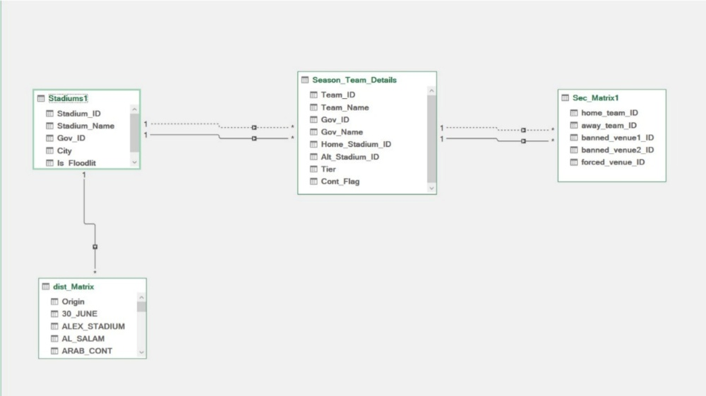
Figure 1: Team & Stadiums Relation Diagram

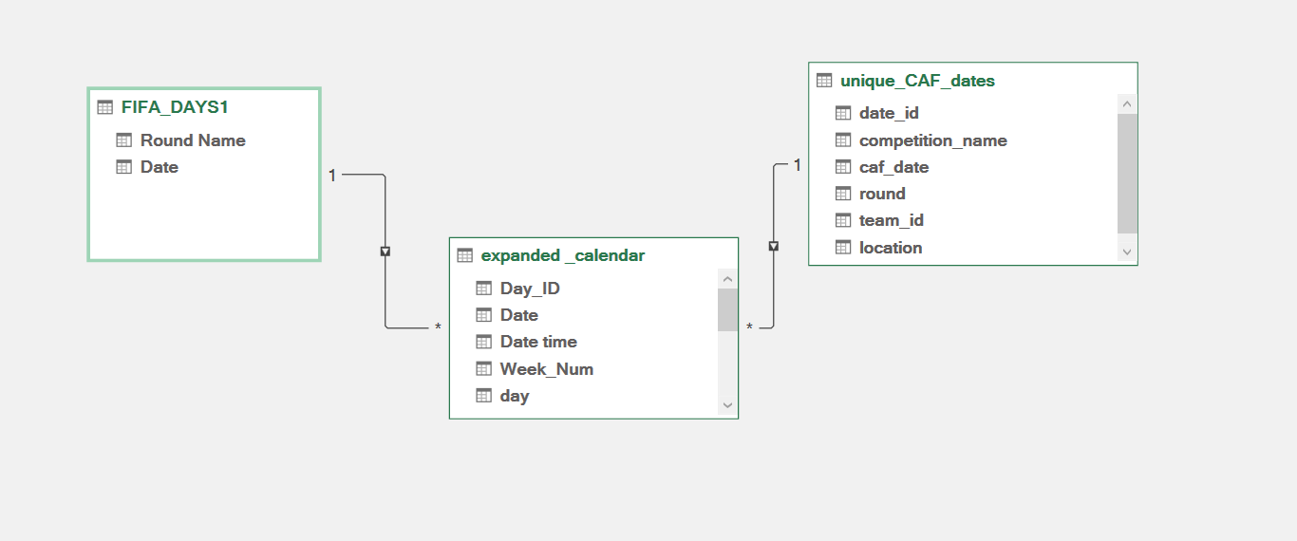
Figure 2:Dates Relationship Model

- Data Integrity: The data was largely used in its original form. Complex cleaning algorithms were not required; instead, the focus was on ensuring that the constraints (such as stadium capacities and security rules) were accurately represented in the Excel sheets.

References

[1] | R. V. Rasmussen and M. A. Trick, "Round robin scheduling – a survey," European Journal of Operational Research, 2008.
[2] | Ahram online, "EPL approve new format for Egyptian Premier League next season," 2024. [Online]. Available: https://english.ahram.org.eg/NewsContent/6/51/532092/Sports/Egyptian-Football/EPL-approve-new-format-for-Egyptian-Premier-League.aspx.
[3] | D. Van Bulck, D. Goossens and F. Spieksma, "Integer programming models for round robin tournaments," European Journal of Operational Research, 2023.
[4] | Ahram online, "Worn-out Egypt players in 'critical zone' due to congested schedules," 2022. [Online]. Available: https://english.ahram.org.eg/News/467780.aspx.
[5] | P. Staats, "Generic Scheduling of Sports Tournaments," Utrecht University, Utrecht, 2009.
[6] | D. R. Goossens and F. C. R. Spieksma, "Soccer schedules in Europe: an overview," Journal of Scheduling, vol. 15, no. 5, pp. 641-651, 2012.
[7] | K. Easton, G. Nemhauser and M. Trick, "The traveling tournament problem description and benchmarks," Principles and Practice of Constraint Programming, pp. 580-584, 2001.
[8] | G. Durán, M. Guajardo and J. Wolf-Yadlin, "Scheduling the Chilean soccer league by integer programming," Interfaces, vol. 37, no. 6, pp. 539-552, 2007.

